  - HISTORIC Preservation MicroLOAN fund guidelines and requirements

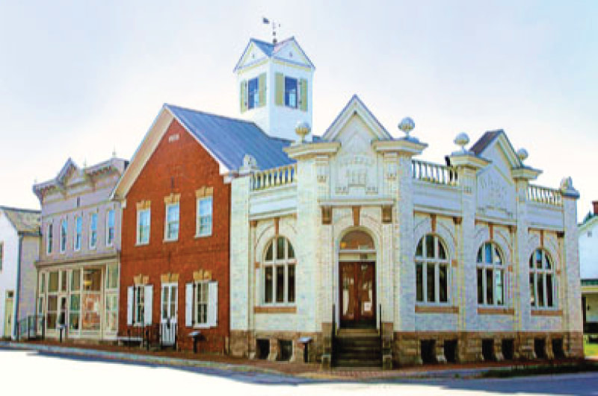  purpose and scope  The purpose of the Historic Preservation Microloan Fund is to enhance PAWV’s mission of historic preservation by lending to projects that facilitate restoration activities for endangered historic buildings and historic commercial districts throughout West Virginia.  The loan fund provides capital, development expertise and technical assistance to property owners who are renovating historic buildings. The loan fund’s primary target market is those owners who are seeking to save an Endangered Property or those who are developing a commercial property that, when redeveloped, will lead to the creation or retention of jobs, new housing units, or other heritage related commercial activity in a commercial downtown district. | eligibility requirements  property eligibility  Funds must be used for the acquisition, restoration, or redevelopment of a building that is:  - Listed on the National Register of Historic Places (NRHP);  - A contributing structure in a NRHP district;  - Eligible to be listed on the NRHP as determined by the State Historic Preservation Office; or  - On the current or past list of PAWV’s Endangered Properties.  borrower type  - Individuals  - For profit business entities  - Non-profit organizations  - Municipalities  - Religious Organizations  loan amount/terms  - Loan amounts, $2,500 - $10,000 repayable over a 24-month term with a 2% fixed interest rate  - Available statewide  - Project must adhere to Secretary of the Interior’s Standards for Rehabilitation  - Non-refundable $100 application fee
application process  The application process is coordinated by PAWV and involves two parts:  1) project eligibility and budget  2) applicant financial information  part 1 – Project eligibility and budget  Complete a PAWV Microloan Application, to include:  - Contact information for the applicant.  - Address of the subject property proposed for rehabilitation  - Evidence that the property is listed on the National Register of Historic Places or eligible to be listed. The preferred documentation should originate from the WV State Historic Preservation Office.  - Narrative description of the overall rehabilitation work to be conducted, with an emphasis on the work being funded by the PAWV loan request.  - Plans and specifications for PAWV funded construction work, which is to be prepared by a licensed architect or contractor.  - Project budget for all construction work including sources and uses of funds.  - A description of project impact. | eligible expenses  - Pre-development expenses such as architectural, engineering, appraisal, conditions assessment, and tax credit consulting for both commercial and endangered properties  - Building acquisition when all other funds have been secured  - Priority is given to construction costs for exterior stabilization or rehabilitation including:  - Front and secondary facades  - Foundations  - Gutters and/or roof  - Windows  - Storefronts  - Signage and awnings only as part of an overall façade renovation  - For Endangered Properties only, priority is given to interior or exterior construction costs that are needed to stabilize the building.
PART 2 – LOAN APPLICATION  The applicant will supply information for PAWV to run a credit check. This will involve sending the following information into PAWV for the underwriting process:  - Personal and/or company financial statements  - Financial projections to determine ability to repay loan  - Two years of tax returns, two months of bank statements, and two recent pay stubs  - Other loans and forms of credit | For assistance with the loan application, contact PAWV at 304-345-6005 or info@pawv.org

